SAR – GPS NAVIGATION & RADIO BASICS
INSTRUCTOR’S NOTES - DRAFT V-6
Please feel free to edit these instructions and pass them to Ralph so that we have a better document next time. Thanks
AS GROUP ARRIVES
-HAND OUT RADIOS AND 64 ST’s (SEE KEVIN),
-Find a partner for this training
-RECORD YOUR NAMES ON THE ATTACHED LIST
WHAT WILL WE COVER
-Basic configuration and use of the GARMIN 64 ST
The way the MWS (Maine Warden Service ) uses their equipment and expects us to use our equipment. They use “BASECAMP”, their PC Based mapping program to:
-Provide us with a GRID Search pattern to follow on our 64 ST,
-which will display our search area and on which we will
-record our search pattern, and
-“Mark” any significant observations for later investigation and
-report our “tracks” when we return with our GPS to the Command Post.

STAY WITH ME; PLEASE WAIT FOR US TO ALL BE TOGETHER.
The 64 ST has many features we will not need to use all and if we invoke or if an individual changes theirs and gets “lost”, we will never get through the basics
-Our Team members experienced with the 64 ST have a different comfort level with other features.
-When we are on a search other Team Members will have different GPS UNITS, Other GARMINs 24, 66’s INREACH etc. all of which are a different and they all have different levels of expertise- so this is realistic
-Save playing with alternative configurations, features and displays for after our basic practice
-I can help with the basics of what the Warden Service expects.
64 ST WALK THROUGH
Check out that your GPS works
-Pick-up the 64 ST GPS
-Remove the rear cover and check for or (install fresh) batteries. Note polarization
Replace and lock rear cover.
-Turn ON by pressing and holding the button on the right hand side, ¾ up from the bottom HARD for a count of 5 until the screen lights up. After it then boots and loads, a screen with a map of our location will appear.
-Quickly press and release the ON button once again- The screen will display:
BACKLIGHT
BATTERY and
GPS and then revert to a map of our location
-Quickly press and release the ON button again (as the second display has already gone away)
Use the LEFT Arrow to select the BACKLIGHT the set the indicator bar to the far right, for maximum BACKLIGHT
-Quickly press and release the ON button again
The Battery and GPS indicators should be full- If not, get another GPS from KEVIN
Press and hold the ON button again to turn the GPS off to save the battery

Check the Position Format (we can skip this if Kevin has already set it on all units)
MEMU MENU ENTER, SCFROLL DOWN TO Position Format enter,
display should be: “Position Format hddd◦mm.mmmm’ Map Datum WGS 84
QUIT QUIT QUIT

Calibrate the Compass
You may need to do this only once during the life of the GPS, but the process takes us past other configuration displays which you may want to change later (on your own) to either make the GPS more useful for you or to confuse the next person who uses this GPS.
Press PAGE, successively, stop at the “Compass” icon, (display)
Press MENU; arrow down to “Calibrate Compass”; press ENTER; (“Start” displays), press ENTER, -then Follow Instructions shown on the GPS
QUIT QUIT QUIT

MARK OUR STARTING POSITION:
-Press MARK
Use the top arrow to move the darkened display to the very top of the screen
-Press ENTER, this will allow you to overlay the number displayed with a location name
The text selection display will probably be on the “A”
Arrow to the right and down to select the “T”, Press ENTER, arrow up and to the left to select the “A”, press ENTER, repeat this to spell out TABLE. Use the open box icon at the bottom of the screen to enter a space, and THEN practice writing something else.
When complete:
Arrow to the bottom highlighting “Done”, and press ENTER
Arrow to the bottom of the next screen and to the right and press ENTER on “Done”
The map of our location will appear.
Press the IN button repeatedly to zoom in, until you can see the “TABLE” tag on your position on the map.
Voila, You have mastered Marking an important FIND (your position location) for the MWS.

-Quickly press and release the ON button again (You should still see 100% Battery and GPS on the screen)
-Press and hold the ON switch to turn the GPS off (Just for fun)

RADIO ORIENTATION

- Pick up Radio, let any optional microphone dangle in your lap or clip it to your shirt near your ear
- To turn the Radio on, Turn the right top VOLUME knob about 3/4 turn clockwise
- Display will first show “HIGHLAND”, then automatically change to “MASAR 1”
- The battery indicator in the upper right of the display should show 3 black boxes, indicating a fully charged battery
- Try to switch to a different frequency by turning the knob to the left of the VOLUME knob in either direction. (If you become bored with this presentation, take a walk out of earshot and listen to the NWS (National Weather Service) on NWS 1-7.
- Return the display to “MASAR 1”
- Hold radio in your right hand, with the bottom in front near your mouth,
- Listen to be certain that no one else is talking on this frequency
- Press talk button, the top large flat switch on left hand side of radio, wait ½ second and say “Radio Check” release the large switch
- Listen for a response.
- If you do not hear a response, or if it is too loud or too soft, adjust the VOLUME knob.
- Turn the Radio off (top right knob counterclockwise) until it clicks.
- Attach Radio to your clothing with the optional, microphone near your ear as it has the speaker
- You are now an expert in turning on the radio and selecting an open frequency.
- The next draft of this will explain the white switches on the front, if I can decipher the icons and functionality, but I digress.

COMMUNICATION STANDARDS (These vary by organization)
Before testing/training with the RADIO
Announce that HISAR is conducting a training exercise on this frequency through 4 PM today.
Use the term SUBJECT if you need to discuss to a lost or injured person

- First, think through what you want to say, (you will speak clearly and not shout)
- To Place a transmission Say: Who you are calling and who you are
  - Example: (press talk button and wait ½ second)
  - Say: COMMAND, THIS IS DAPHNE (and release the talk button)
- You will receive a reply: DAPHNE, THIS IS COMMAND, GO AHEAD
- Press the talk button, Speak your message, and release the talk button
- Carry on a conversation with the other party
- If you don’t receive an immediate reply from COMMAND or whomever,
  - wait a while then repeat #2
  - check that the Volume is turned up
  - wait a while then repeat #2
- When finished, say something like Daphne Clear

LEAVE the Radio ON as we will use it in the next training exercise

LET’S PRACTICE A GPS-ASSISTED HASTY SEARCH
Assume that it is 7:45 AM “The Dogs” (Warden and MSARD) have already been out, are in having breakfast and taking a break and the ground searchers (us) have had a briefing:

A 56 White Female, some memory loss, has been despondent previously but was in good spirits yesterday, except that it was raining (hard) and is cold-36 degrees and got down to 33 last night and she did not return home. Last wearing dark pants, a green shirt and brown hat, probably had her water bottle as she is an avid outdoors person. She was last seen alone by friends who were walking their dog, as they were heading home at dusk yesterday. The CP Phone number is 207 667 2005

Below is a map created in “BaseCamp” of part of Sharon’s Farm. The yellow lines are “tracks” of prior GPS routes, generally following paths in the woods and are ideal tracks for making a hasty search, according to the landowner, also a very experienced S&R person. The “rectangle” in the lower left simulates what we would be given as a SEARCH GRID by the MWS if that were the only overlay, but this map is prepared for both a planned Hasty Search and Grid Search.
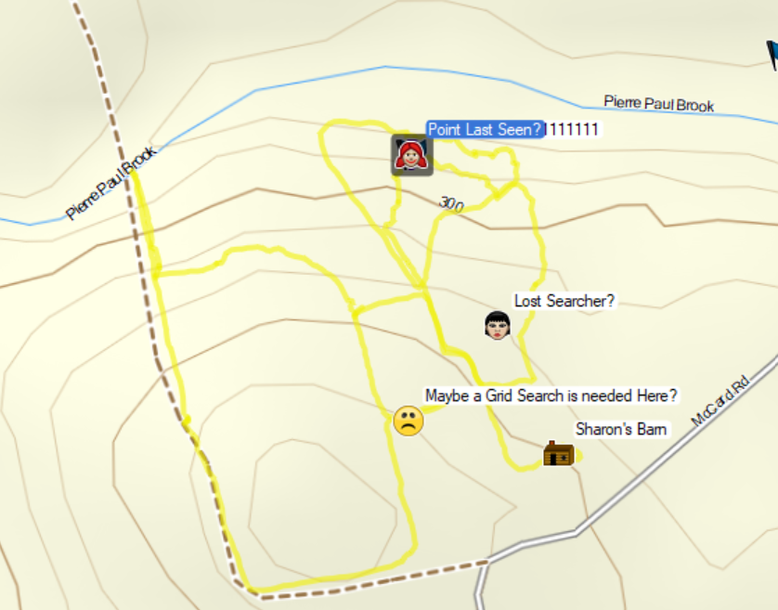
Memo: GPS x-reference for Route Planner –“Hastyy 6-18”Information collected by MWS from the dog’s search
MAP | NAME | SEQ | LAT (WGS 84) | LONG
 |  |  | MENU MENU “Waypoint Manager” name on this chart, ENTER
Sharon’s Barn | Barn 1 | 1 | N 44◦56.7541’ | W 069◦02.9553’
Green Camper /Lost Searcher | Point 6 | 2 | N 44◦56.8697’ | W 069◦03.0263’
Point Last Seen/Downhill Insulation | Point 5 | 3 | N 44◦57.0324’ | W 069◦03.1201’
Maybe a Grid Search is needed Here | Point 1 | 4 | N 44◦56.7813’ | W 069◦ 03.1289’
DISREGARD THIS PAGE:
SARTOPO IS PROBABLY A BETTER CHOICE FOR A SEARCH BUT INCONTENT WITH MWS
It occurred to me, while putting the last draft of this together, that the LAT LONG information map and compass etc. is excessive and unnecessary if we have a loaded GPS with extra batteries.

LAT LONG, pencil ,ruler ,a folded waterproof map, remembering Red in the Shed on the Compass , applying declination, variation, converting from Magnetic to True (West is best, East is least), deciphering decimal or degrees of LAT and LONG and finding the correct scale on the map and using a line of sight restricted walkie-talkie radio rather than a CELL Tower encumbered IPHONE, or better yet an INREACH text communicator, is similar to starting an old car by pumping the gas pedal, pulling out the choke, listening for a start noise and repeating the process vs. pressing the brake pedal and the start button in a $20k car today.

So enjoy the GPS and remember to bring extra batteries. And the GPS is only slightly better than the old car. If we have and use SAR TOPO on an IPHONE, where we automatically see our position, track, a topo map of the area and the position of our other team members. But that practical training is for another day and NOT consistent with our traditional support of the MWS . (and we will also need an external power supply for the IPhone)

Here is a SARTOPO Map of today’s training –Note that it includes Lat. Long. (but I haven’t worked with it enough to get it on my IPHONE or “clean up the labels”. I’ll leave that for another day
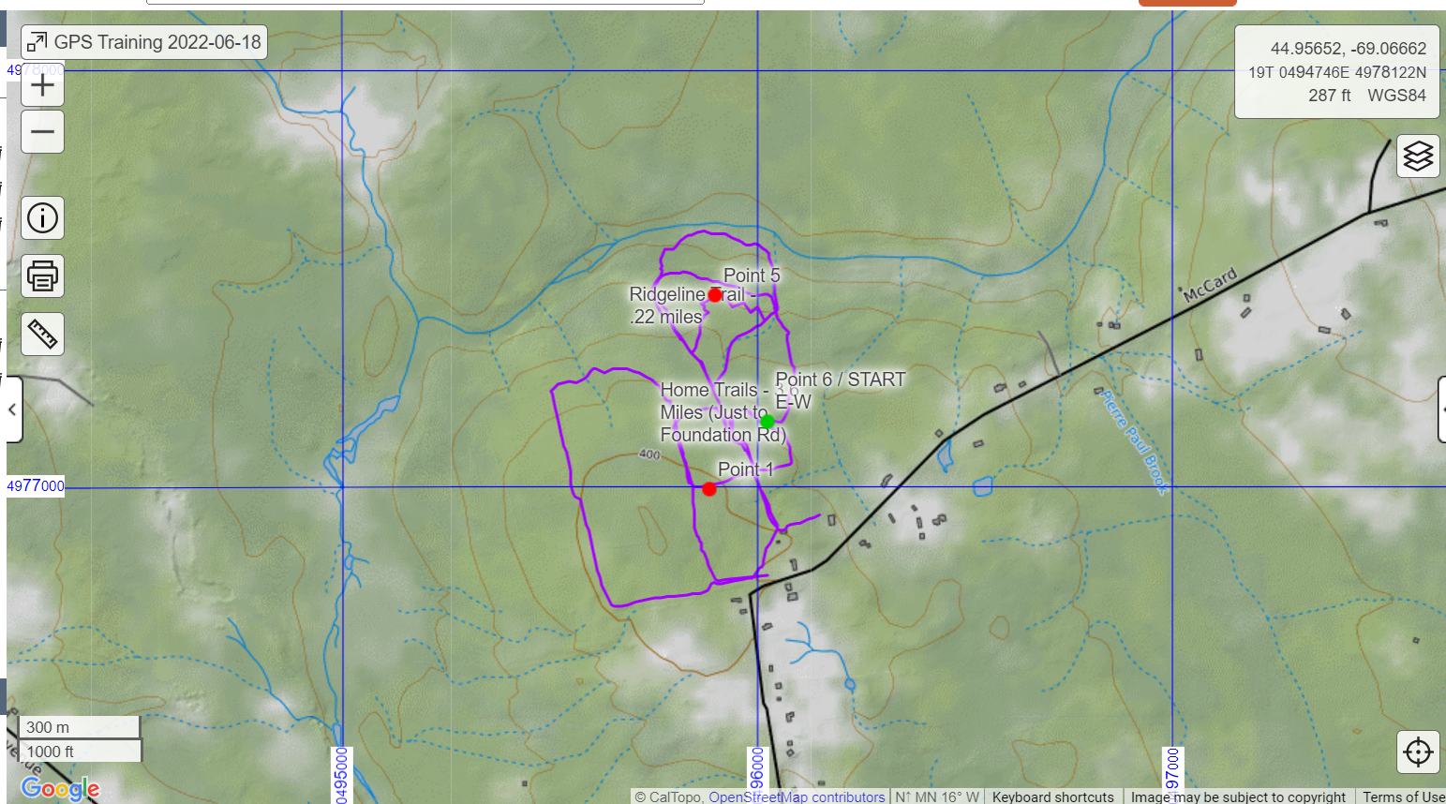
I definitely need to work with this system to”
-get it in an iPhone / iPad and to -see other searchers positions

Starting near Sharon’s Barn (closer to the house will be best to allow the system to acquire the exact Barn location used in our Track Manager “download”)
-We will First Navigate to “Sharon’s Barn”, using “HASTYY 6-18” from Track Manager, downloaded to your GPS from the CP or follow one of the tracks in yellow and then MARK the location on your GPS
-Then navigate to “Lost Searcher?” for their help, and MARK the location on your GPS
-Then navigate to “Point Last Seen?”, and MARK the location on your GPS
-Then navigate to the box where “Maybe a grid Search is needed here?” and MARK the location on your GPS
-Then navigate back to Sharon’s Barn and download your completed search track to the CP PC, and if we remember, we will save our Tracks/Route (normally we are so excited to be finished that we forget to do this).

LOAD (RECEIVE) THE SEARCH ROUTE ONTO YOUR GPS
-We will download from the Command Post or from a member’s GPS the Search GRIDs called a ROUTE (MENU MENU then arrow to “Route Planner”) on your GPS . (This is what the Warden Service will provide to the searchers in a real search)
-FIRST Press and hold the ON switch to turn the GPS ON (Wait for the GPS to Boot/Load. The map of our location should then display)
Press MENU, MENU, arrow down to “Share Wirelessly” press Enter
Arrow down to “Receive” and press Enter
(By now, Someone should be sending the ‘SEND WIRELESSLY ROUTES HASTYY 6-18” from their GPS )

AFTER RECEIVE IS COMPLETE, Display the Search GRID from the CP (like the Warden Service) on your GPS
Press MENU MENU
Scroll to and highlight “Track Manager”; press enter,
Scroll to “HASTYY 6-18”, press ENTER; Scroll to “View Map”, press ENTER
Start your walk, following the Tracks created by the CP displayed on your GPS.

OPTIONAL:
Reset statistics which the GPS accumulates during this search
To clear the TRIP Computer:
-On the 64 ST, PAGE to the “Trip Computer” icon and display
MENU; Reset, ENTER, Display “Reset Trip Data, Timers, etc.,” (Bar); ENTER, scroll up to “Yes” ENTER, QUIT; Your Speed, moving Time and other statistics for this next “walk” have been reset to zero and will immediately start to accumulate. You may look at these statistics anytime during your walk to see what you have done since you “Cleared the TRIP Computer”

View the Statistics which the Compass function displays during your search (this walk).
-PAGE to “Compass”
Based on your Route you specified using:
MENU, MENU, scroll to Route Planner; Scroll to a names Route, ENTER, Scroll to “View Map”, ENTER, GO, the MAP display will show your current position and progress toward the destination you specified in your selected Route from Route Planner;
PAGE ing to “Compass” will display the statistics which the Compass function is recording during your search (walk).

On the GPS select PAGE MAP, and Start to walk adjacent to the track from the Barn-you may want to occasionally select PAGE Compass to get an idea of your direction (disregard Distance, ETA and “Time to next “for now. We will look at that later.-you may want to occasionally look at ”PAGE”; “Trip Computer” to see the trip statistics. -Return to PAGE MAP and follow the yellow track to “Point Last Seen” (looking around for the lost subject).
Then, when close to Sharon’s Barn –Your first (and may be your last) waypoint
RADIO THE COMMAND POST WITH YOUR PROGRESS
1 | You |  | HISAR Command this is team 1 Mat
2 | Expected Response |  | Team 1 Mat, this is HISAR Command, go ahead
3 | You |  | Command, Team 1 Mat has reached Sharon’s Barn, no Subject Observed
4 | Expected Response |  | Team 1 Mat, We Understand, you have reached Sharon’s Barn, MARK on your GPS Continue to Lost Searcher for their help
5 | You |  | Command Mat, We will MARK PLS on our GPS and Continue to find the lost searcher
6 | Response |  | Mat that is correct. Command Clear
7 | You |  | Mat Clear
RECORD ON THE GPS WHERE YOU HAVE ARRIVED
(On a real search this may be where you have found a clue)
Establish a Waypoint on the Map |  | -MARK; arrow up to top, ENTER and  -establish a name for your waypoint like “PLS No One ”  -Arrow to Done and ENTER  Arrow down to Done (yes, once again) and ENTER
Continue on your grid/hasty search, but on this leg, or if you have trouble, navigate to a Waypoint destination
Use the GPS to navigate to a known Waypoint | MENU; Waypoint Manager; Arrow to a known Waypoint like “Lost Searcher” ENTER  (Note the compass direction and distance to see if this makes sense or if you may have made a mistake)  Arrow down to Go  -PAGE; COMPASS  Note the distance, direction, ETA and Time to this Waypoint  -PAGE;MAP note and follow the Pink track, alternatively looking at the  -PAGE Compass; and  -PAGE Map; and  -PAGE Trip Computer
Continue your Hasty Search, (it is OK to stay on a path/road if you don’t want to walk in the woods during this exercise. You will probably get back to the barn eventually.
When you arrive at each waypoint,
- RADIO COMMAND WITH YOUR PROGRESS, see instructions you used when you first arrived at at the Barn, above
- RECORD ON THE GPS WHERE YOU HAVE ARRIVED, see instructions you used at the barn, above
Continue your hasty/grid search,
When you arrive back at the barn, memorialize your Search (Track)
Save Track (Save a Search) | MENU; arrow to Track Manager; Current Track Enter; Save Track; Enter; Change the name, I like to retain date and Time as part of the new name  Done; Yes QUIT

Even if you don’t like your results, Archive the track so that you can see this search later on this GPS

Archive your Track | MENU; Track Manager; Arrow to your track (recently created and renamed)  Arrow to Archive; ENTER; QUIT

OTHER CONFIGURATION INSTRUCTIONS-(Try these If you become bored)
 | Activity | Task | GPSMAP 64 st
1 | Set-up GPS | On /Off (then wait for maps + to load | Press and release switch on RH Side for 3 seconds
2 | Set-up GPS | Battery status | Press right side “on/off” button at any time  Rechargeable battery is automatic when USB is connected
3 | Set-up GPS | Date and Time | Press right side “on/off” button at any time
4 | Set-up GPS | Backlight-adjust | Press right side “on/off” button at any time -arrow left or right
5 | Set-up GPS | GPS signal strength | Press right side “on/off” button at any time
5.1 | Configure Units | Units of:  Distance and Speed –Statute  Elevation -Feet/min  Depth–Feet  Temperature-Fahrenheit  Pressure-Inches (Hg) | Menu; setup arrow down to Units; ENTER; select with arrow; enter
5.2 | Configure  Time | Time  Time Format-12 Hour  Time Zone-Automatic | Menu; setup arrow down to Time; ENTER; select with arrow; enter
5.3 | Configure Position Format | Position Format  H ddd mm’ ss.s”  Spoken as:  (North/West, words are often omitted since the order is obvious)  North 44 Degrees 36 Minutes thirty point five Seconds  West Sixty Eight (068 )Degrees Thirty Five Minutes, thirty one point 3 seconds | Menu; setup arrow down to Position Format; ENTER; select with arrow; enter
5.4 | Configure Heading | Display-Directional Letters  North Reference-True  Go to Line(Pointer)-Bearing Large  Compass-Auto  Calibrate Compass-Follow Instructions on GPS | Menu; setup arrow down to Heading; ENTER; select with arrow; enter
5.5 | Configure Share wirelessly | First decide what you want to share  Waypoints-A point on a map  Routes-May have been outside of a rectangular grid  Tracks-Where you have walked, or the outside of a free form “grid” used in a search  : | Menu Menu;Share Wirelessly;Arrow down to Send or Receive enter, arrow down to item to share; Enter;Send
6 | While searching | What is your Compass heading (or where the GPS is pointing?) | Press: PAGE; stop on “Compass”
7 | While searching | Display your Speed | Press: PAGE; stop on “Compass”
8 | While searching | Your Distance to the next point (waypoint) | Press: PAGE; stop on “Compass”
9 | While searching | ETA at your Destination (probably a waypoint) | Press: PAGE; stop on “Compass”
10 | While searching | The time to your next destination (probably a waypoint) | Press: PAGE; stop on “Compass”
11 | While searching | Display the MAP | Press: PAGE; then stop on “Map”
12 | While searching | View more of the MAP | Press “IN” for more detail  Press “OUT” for less detail  Press”↑”, “→”, “↓”, “←” to move on map
13 | While searching | Record a Location on the “GPS MAP” | #1 See Map-Display  #2 Press “MARK” to Record the Current location on the map or  #3. Use “View other than your current Location” (described above) to view another Location, then press “MARK”  #4 Arrow up (”↑”) to change the default text to name your new Marked Position. Press Enter  #5 Arrow through numbers, alphabet and special characters to name your new Marked position  #6 Arrow down to “Done” to save your “New Marked Position’s Name”  #7 Arrow up to “NOTE” press enter and write something descriptive Arrow down to “DONE” and press “ENTER” or you will lose everything.  #8 Arrow down to bottom right and press “ENTER” or you will lose everything.
14 | While searching | Establish a Waypoint on the Map | -MARK; arrow up to top, ENTER and  -establish a name for your waypoint like “Alpha Ralph”  -Arrow to Done and ENTER  Arrow down to Done (yes, once again) and ENTER
14.1 | While searching | Use the GPS to navigate to a known Waypoint | MENU; Waypoint Manager; Arrow to a known Waypoint like “Waypoint Bravo” ENTER  (Note the compass direction and distance to see if this makes sense or if you may have made a mistake)  Arrow down to Go  -PAGE; COMPASS  Note the distance, direction, ETA and Time to this Waypoint  -PAGE;MAP note and follow the Pink track, alternatively looking at the  -PAGE Compass; and  -PAGE Map; and  -PAGE Trip Computer
15 | While searching | Clear to allow a clean record of a TRACK This will allow you to begin recording “CURRENT TRACK” | PAGE; Trip Computer; MENU  -Arrow to Reset; enter  -Arrow to ”Clear Track and Trip Data Reset Both”, ENTER”;  -Are you Sure; Arrow to YES and ENTER  -QUIT
16 | While searching | Save a Track (will only work if you have moved) | MENU  Arrow to Track Manager  Arrow to Current Track  ENTER Arrow to Save Track ENTER  Done ENTER  Current Track Saved arrow to Yes aand ENTER
17 | While searching | Rename a Track | MENU  Arrow to Track Manager  Arrow to Track  Arrow to Change Name ENTER  Change Name Arrow to Done and Enter  Quit
18 | While searching | Establish a Waypoint on the Map | -MARK; arrow up to top, ENTER and  -establish a name for your waypoint like “Alpha Ralph”  -Arrow to Done and ENTER  Arrow down to Done (yes, once again) and ENTER
19 | While searching | Navigate to a known Waypoint | MENU; Waypoint Manager; Arrow to a known Waypoint like “Waypoint Bravo” ENTER  (Note the compass direction and distance to see if this makes sense or if you may have made a mistake)  Arrow down to Go  -PAGE; COMPASS  Note the distance, direction, ETA and Time to this Waypoint  -PAGE;MAP note and follow the Pink track, alternatively looking at the  -PAGE Compass; and  -PAGE Map; and  -PAGE Trip Computer
20 | Immediately After a Search | Save Track (Save a Search) | MENU; arrow to Track Manager;Current Track Eenter; Save Track;Enter; Change the name, I like to retain date and Time as part of the new name  Done Yes QUIT
21 |  | Archive your Track | MENU; Track Manager; Arrow to your track (recently created and renamed)  Arrow to Archive; ENTER; QUIT
DFegrees minutes point seconds North
Degrees minutes point seconds West

Saved from Users Whedon Desktop GPS TRAINING Exercise to Lorna MASAR 2021-02-11

